Frodsham Neighbourhood Plan Steering Group Meeting
Monday 27th January 2020 at 1.30pm Castle Park House
Attendees:
Peter Vickery, Resident
Steve Carmody, Resident
Chris Burrows, Resident
Martin Maris, Resident
Andrew Rowe, Resident
Caroline Ashton, Resident, FTC
Ashley McCraight, Resident
Gill Hesketh, Support and Admin, Resident
Apologies: Fiona Barry, Mark Warren.

The Neighbourhood planning process:
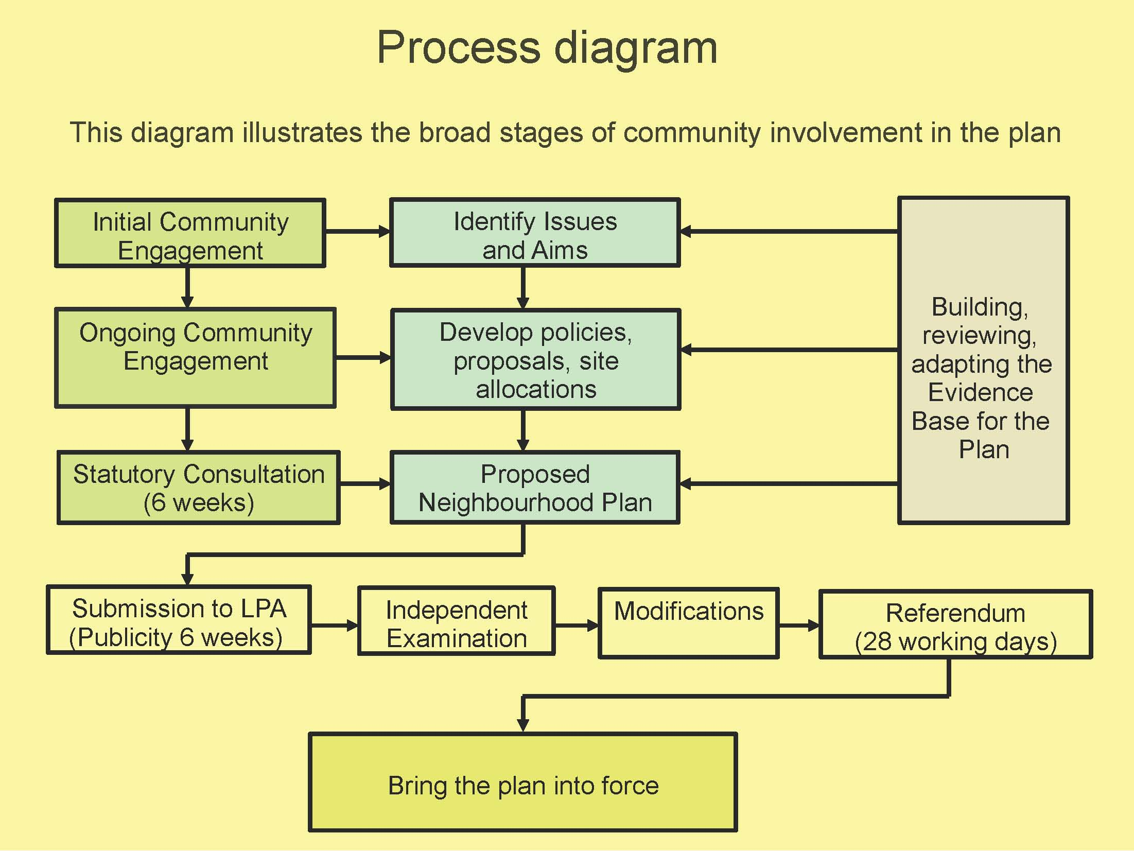

GH tabled the document above and explained that the group were at the “develop policies, proposals, site allocations” stage. Sub groups have been working on drafting policies which have been sent to Neighbourhood Planning specialist staff at CWaC Planning Department for their comments and feedback. Feedback had been received and the sub groups now need to revise the draft policies based on the feedback.
Forward plan
It was agreed the sub groups would continue to meet and work on the draft policies and produce other elements of the final Plan such as the Introduction, basic conditions statement and consultation log.
AOB
CA said she had recently been supporting residents wishing to comment on a planning application in her ward. She identified that some residents were unclear about the planning process and how they could comment on applications. The influence that Frodsham Town Council has on local applications was not clearly understood based on CA’s experience. The group suggested it would be useful to have a diagram of the planning process for future events and for use during the consultation process. GH to see if CWaC have a diagram.
The meeting closed at 2.30pm
Next meetings:
No dates for further meetings have been set whilst the sub groups continue to draft policies.

Action from this meeting:
ACTION | OUTCOME
- Policy writing subgroups to continue with drafts | ongoing
- GH to ask CWaC for a planning process diagram | 28/1/20

