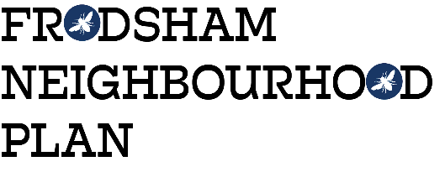
Steering Group Meeting - Monday 27th November 2017 at 1.30pm Castle Park House
Attendees:
Martin Maris, Resident
Caroline Dillon, Resident
Caroline Ashton, Resident, FTC
Gill Hesketh, Support and Admin, Resident
Apologies: Liam Jones, Mark Warren, Steve & Lynn Carmody, Peter Vickery
The minutes of the last meeting were accepted with the addition of apologies from Caroline Dillon. Actions 1 & 4 were complete, actions 2 & 3 are ongoing.
December twitter Schedule
The draft tweets for December had been circulated by MM, there were discussed and additional ideas given.
Information from Gill Smith
The information received from GS at CWaC Planning was discussed and it was agreed that an A0 size map showing all the planning constraints relating to Frodsham, such as green belt, flood plain, conservation areas etc. would be a useful starting point to consult with the community about any possible areas for development. GH to contact CWaC to see if it’s possible.
Maps
GH had enlarged the map of Frodsham so the public can identify the green spaces they use. It was suggested that consultation should take place in January by having a staffed display in Morrisons and the library; dates & staffing to be agreed at the next meeting.
Registering Assets of Community Value
No further responses yet.
Meeting with Beverly Wilson, Insight & Intelligence manager CWaC
Members were asked to review the “Your Voice Matters” survey that CWaC has conducted and identify what Frodsham specific information we can get from the survey that will provide evidence for the Plan. MM to contact Beverly and suggest a meeting date early next year.

Developer contact
Tony Clowes from Positive Location Properties in Alderly Edge has been in contact to request a meeting to discuss a development on land behind the Old Hall. The group had concerns about being seen to favour particular developers, and that the developer may be seeking to get the Plans support for their development proposal which is not within the remit of the Plan. The group agreed to revisit the request in the new year when potential development areas would be clearer. GH to send an email to him.
AOB:
MM reminded the group to look at the circulated a list of community groups and to add to or amend based on their knowledge.
MM suggested we send a e-Christmas card to anyone who has interacted with the Plan and asked for the group to provide all contacts at the next meeting.
NOTE: FTC has requested an update on the Plan’s progress for their next meeting on 22nd January 2018
The meeting closed at 3.30pm
Next meeting; MONDAY, 11th DECEMBER 1.30pm at CASTLE PARK HOUSE.
Subsequent meeting; Monday, 15th January, 1.30pm Castle Park House
Action from this meeting:
ACTION | OUTCOME
- GH to request map from CWaC | Map to be ready by 15/12/17
- All to review the list of community groups and amend as necessary
- Golf Club, Warburtons, Woodhouse Plumbers & Helter Skelter employer surveys to be chased | ongoing
- GH to contact Positive Location Properties | Sent 29/11/17
- All to review data from CWaC survey

