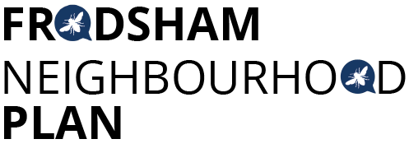
Steering Group Meeting - Tuesday 27th November 2018 at 1.30pm - Castle Park House
Attendees:
Chris Burrows, Resident
Mark Warren, Resident (until 2.35)
Caroline Ashton, Resident FTC
Ashley McCraight, Resident
Martin Maris, Resident
Andrew Rowe, Resident
Peter Vickery, Resident
Gill Hesketh, Support and Admin, Resident
Apologies: Steve Carmody, Lynn Carmody.
The minutes of the last meeting were accepted. GH & CV have not yet drafted the Twitter schedule for January
Twitter Schedule for December
MM had circulated the draft schedule and asked for further suggestions. GH & CA to draft schedule for January.
AECOM Update:
Feedback on the initial draft of the Masterplanning report had been sent to AECOM. In order to get the level of detail required for the identified sites, there needs to be a “design standard” report. GH has arranged for the extra funding from AECOM to include design standards in the report being prepared.
Draft Policies:
After much discussion and feedback, a final format for writing policies was agreed. GH to circulate. All to re-draft their policy into the agreed format and send to GH & PV. PV offered to edit all the contributions and is also developing the overall draft Plan.
Communications Strategy and Public Consultation:
There was a debate about whether the steering group were required to conduct a six-week consultation before the draft plan is submitted to the LPA. GH to ask the LPA. GH also to ask LPA for good examples of consultation strategies other Plans have used.
An outline strategy for public consultation was agreed;
- Initial leaflet campaign: leaflet to outline the draft Plan and invite the community to two public events to discuss the draft. This information will also be on the website
- Two public events, one day time, one evening to talk face to face with the community
- A structured questionnaire asking for specific feedback on draft policies to be posted out to every household in Frodsham
AOB
GH had received an email forwarded from FTC from an organisation offering free aerial photographs. MM has offered to pursue this.
The meeting closed at 3.30pm.
Next meetings:
Tuesday 11th December 2018 at 1.30pm
Monday January 7th 2019 at 6.30pm
Tuesday 22nd January 2019 at 1.30pm
Tuesday 29th January 2019 at 1.30pm

All at Castle Park House

Actions from this meeting:
ACTION | OUTCOME
- GH to send circulate revised pro forma | Email sent 27/11/18,
- All to re draft statements for their policy in the revised format
- GH to check if 6-week consultation is required | Response from LPA confirms 6-week consultation is required. Information circulated 28/11/18
- GH & CA to draft Twitter schedule for January

