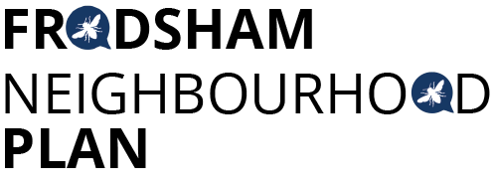
Steering Group Meeting - Monday 1st April 2019 at 6.30pm Castle Park House
Attendees:
Caroline Ashton, Resident FTC
Martin Maris, Resident
Andrew Rowe, Resident
Chris Burrows, Resident
Steve Carmody, Resident
Peter Vickery, Resident
Ashley McCraight, Resident
Liam Jones, Resident FTC
Gill Hesketh, Support and Admin, Resident
Apologies: Mark Warren
The minutes of the last meeting were accepted, all actions complete.
Draft Plan Exemplars:
PV presented an exemplar of a section of the draft Plan. An explanation of the structure and possible content was discussed, and questions answered by PV, AMcC & SC. The group thought the structure was logical and agreed to start writing their allocated policies against the exemplar format. Policy writing sub groups to arrange meetings to draft policies.
Consultation Framework
A sub group of MM, CB, LJ and GH had met to produce a process for consultation on the draft plan and for the formal “regulation 14” six-week consultation. The process and ideas were discussed and agreed in principle. It was noted that nothing could be done until a draft plan had been considered by CWaC planning department. CB offered to produce a timeline for the consultation process.
Website
The revised website is now up and running. PV is to provide all the “missing” minutes to CB for adding to the website.

Master Planning Report
AECOM had sent a query about some additional text for the report, which was discussed. GH to email AECOM about the text and chase the final version of the report. AECOM will join the meeting on 14th May to discuss the Design Codes report.
AOB
Castle Park House is not available as a venue for the evening meeting on 29th April - all to research other (free) venues.
AMcC tabled a useful document about how to report a pothole to CWaC. This will be added to the FTC website.
The meeting closed at 8.00pm.
Next meetings:
Tuesday 16th April at 1.30pm

Monday 29th April (venue TBC)

Tuesday 14th May at 1.30pm

All at Castle Park House
Actions from this meeting:
ACTION | OUTCOME
- GH to contact AECOM re text for Masterplanning report | Sent 2/4/19
- Editorial group to continue. | Ongoing
- Policy writing sub groups to continue with drafts
- Timeline for consultation to be prepared by CB
- All to try to source free meeting venues

