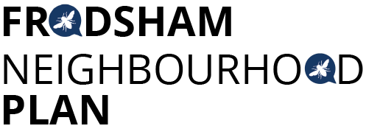
Steering Group Meeting - Monday 29th April 2019 at 6pm Castle Park House
Attendees:
Caroline Ashton, Resident FTC
Martin Maris, Resident
Steve Carmody, Resident
Chris Burrows, Resident
Ashley McCraight, Resident
Peter Vickery, Resident
Liam Jones Resident FTC
Gill Hesketh, Support and Admin, Resident
Apologies: Mark Warren, Andrew Rowe
The minutes of the last meeting were accepted, actions 2 & 6 ongoing.
Draft Policies
The sub-groups continue to develop draft policies based on the exemplar from PV. All draft policies to be ready for the meeting on 11th June. An additional meeting on 2nd July 9.30 to 12.30 was agreed to review the draft Plan. The meeting on 9th July has been extended to 4.30 to provide time for review of the Plan.
Festival in the Park 7th July
The group agreed it would be a good opportunity to continue consultation and raise our profile with the community by having a stand at the Festival in the Park. Staffing of the stand was agreed as:
1pm to 2pm - MM & GH
2pm to 3pm - CB & SC
3pm onwards - PV
CB & SC offered to set up the gazebo
PV to try and source a gazebo from the Arts Centre.
Some suggestions for displays included the evidence graphs, synopsis of draft policies and possibly a further questionnaire.
Helsby High School Survey
AMcC is trying to arrange a suitable meeting with HHS to explore adding questions to the Student Voice Survey. PV is seeking information from the last survey and presentation the HHS students made at the first consultation meeting.

Meeting Locations & Times
We are still struggling to find suitable meeting venues for monthly evening meetings.
The following were proposed:
28th May meeting at the Leisure Centre 7-8.30pm (MM to confirm)
24th June meeting at the Arts Centre 7-8.30pm (PV to confirm)
22nd July meeting at the Conservative Club 7-8.30pm (LJ to confirm)
19th August meeting at the Leisure Centre 7-8.30pm (MM to confirm)
The room hire costs will come out of the FNP budget.
AOB
MM had produced an analysis of the FNP Facebook statistics from the past two years which was agreed as good evidence of consultation. The statistics up until the end of 2018 will be used. Further statistics will be analysed when the formal consultation process is underway.
Agenda item for next meeting is considering what we need to include in the next budget bid for funds.
Next Meetings:
Tuesday 14th May at 1.30pm Castle Park House
Further meeting venues TBC, dates above

Actions from this meeting:
ACTION | OUTCOME
- GH to send comment re Masterplanning report to AECOM
- Editorial group to continue. | Ongoing
- AMcC & PV to pursue student survey information and meeting
- Policy writing sub groups to continue with drafts, deadline 11th June | ongoing
- Timeline for consultation to be prepared by CB
- MM, PV & LJ to confirm meeting venues
- PV to source gazebo for Festival in the park

